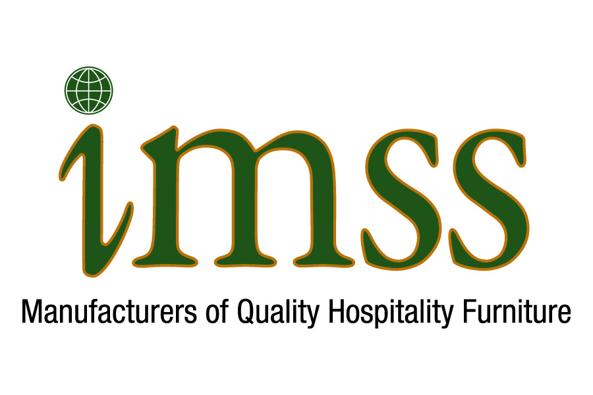
IMSS INTERIORS

LETTERS OF RECOMMENDATION

To Whom It May Concern:

Below you will find Letters of Recommendation (LORs). They all came as unsolicited “thank you notes” and commendations - due to our standard above-and-beyond service given to each and every Client. More are available upon request. In addition, more are available through personal phone calls, when our clients’ corporate policy forbids written recommendations. However, the P.M.s from such firms as Starwood, numerous Gensler offices, various purchasing firms and other clients would be happy to take your phone call.

We put our Clients’ 100% satisfaction above all else – to ensure long term relationships.

Thank you for taking the time to review the LORs.

Best Regards,
Michael A. Gompertz
President

1415 Oakland Blvd . Suite 202 . Walnut Creek, CA 94596
P: 925-258-9909 . F: 925-258-9908 . www.imssltdinteriors.com

From: Rob Shank [mailto:Rob.Shank@Hilton.com]
Sent: Monday, December 23, 2013 4:13 AM
To: mgompertz@imssltd.com
Subject: A Big Thank you!

Mike - thank you to you and your company. We know shipping is not as gentle as we are, but You and your company responded very quickly, and got us what we needed just in time. Mike, it is nice to know that there are some suppliers that treat their customers just like the Hilton family of hospitality treat their customers. Keep up the good work. You and your company performed beyond our expectations. Thank you again for walking your talk.

ROBERT SHANK I Chief Engineer

HILTON HARRISBURG
t: +1 717 237 6417 I f: +1 717 233 6830
1 North Second Street I Harrisburg PA 17101 I United States
hilton.com I harrisburg.hilton.com I facebook.com/HILTONHARRISBURG

www.hiltonharrisburgdining.com

To whom it may concern,
My name is Scott Berkowitz; I am the lead developer of the Aloft Hotel in Beachwood, Ohio. I’m please to say we opened the hotel on November, 19th of 2013.
After considering multiple case good providers, we chose to go with IMSS. It’s a very important decision, and I can now confidently say it was the right one.
The product was excellent, but the differentiator for me was the level of service. They are truly a seven day a week manufacturer, available at all hours. It’s unfortunate that this is the new business paradigm, but the 9-5 work day is all but gone. This work ethic and attention to detail is evident throughout the entire IMSS team. They seemed to always be informed, even if I just had a one on one conversation with Mike Gompertz.
For example, we had misplaced a few of the window surrounds which I communicated to Mike. Not thirty minutes following, I received an email from Steve (a member of the team) with tracking information for the additional surrounds needed.
Mike Gompertz is a man of integrity, and IMSS exceeded my high level of expectation.
Please feel free to contact me directly to discuss further.
Sincerely,
Scott Berkowitz
Boutique Hotel, LP
Aloft Hotel – Beachwood
Managing Partner
Direct: 216-570-9400
Email: scottberkowitz2@gmail.com



